

**Polling District and Polling Place Review 2025**

**Castle Ward**

**Parliamentary Constituency:** Cramlington and Killingworth

**(Proposed) Polling Districts:** E01, E02

(At Parliamentary elections electors in E01 and E02 are the responsibility of Northumberland County Council)

**Parliamentary Constituency:** North

**(Proposed) Polling Districts** E03, E04, E05

The Local Government Boundary Commission for England are an independent body accountable to Parliament. They are responsible for reviewing councils to make sure their patterns of internal wards are fair and sensible. Their reviews include at least two rounds of public consultation before they make recommendations for change.

The final recommendations were published on 7 January 2025, and the new arrangements apply to local elections from 2026.

As a result of changes to ward boundaries the Acting Returning Officer (ARO) is conducting a review of polling districts and polling places to ensure that they are suitable for the new ward boundaries.

For more information on the local government boundary review visit: <https://www.lgbce.org.uk/all-reviews/newcastle-upon-tyne>

This document provides details of the review, along with the initial recommendations and comments of the Acting Returning Officer (ARO). Also, the election rules require the ARO to decide how many polling stations are required for each polling station and the ARO must allocate electors to the polling stations in such manner as they think most convenient.

These recommendations will be open to all residents, stakeholders, and any interested parties. We shall be seeking representations from local disability groups on the accessibility and suitability of polling places. Any comments should be addressed in the first instance to pollingplaces@newcastle.gov.uk where they will be collated on behalf of the (Acting) Returning Officer.

We considered the following factors:

* **Identifying new polling places:** We will look for new polling places in areas where the existing provision is unsuitable or unavailable.
* **Feedback:** We will consider feedback received following recent elections, consultation from members of the public, elected members, and other stakeholders.
* **Accessibility:** We will try to ensure that every polling place is accessible to electors with disabilities.
* **Facilities**: We will make sure that all electors have such reasonable facilities for voting as are practicable in the circumstances.
* **Elector numbers:** We will try to comply with the Electoral Commission guidance on the maximum number of electors that should be allocated to a polling station which should not exceed 2,250.
* **Future housing developments**: We will consider the impact of proposed housing developments on polling station electorates.

**(Current) Castle Ward**

This map shows the current ward and polling district boundaries and the polling places

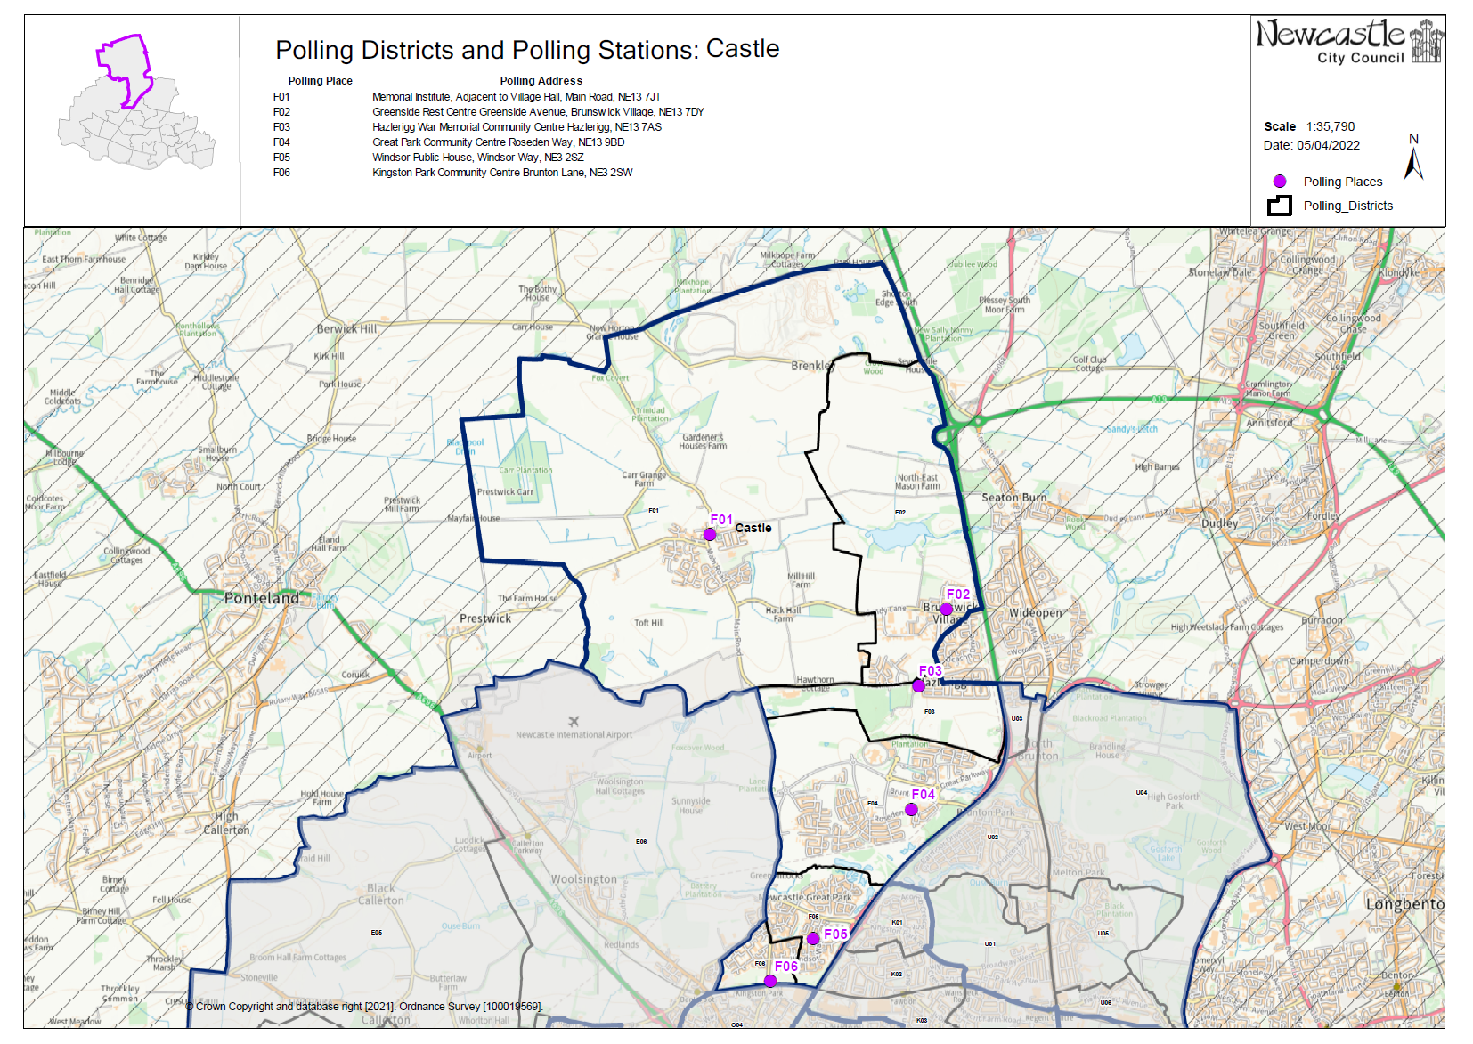

**(New)**

**Castle Ward**

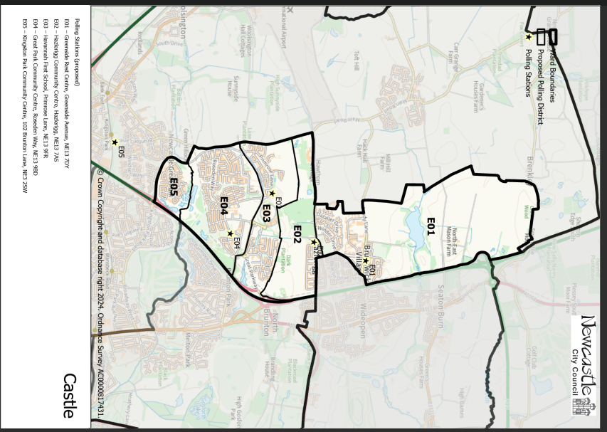

This map shows the new ward and the proposed polling districts and the proposed polling places.

* **E01** – Greenside Rest Centre, Greenside Avenue, NE13 7DY
* **E02** – Hazlerigg Community Centre, Hazlerigg, NE13 7AS
* **E03** – Havannah First School, Primrose Lane, NE13 9FR
* **E04** – Great Park Community Centre, Roseden Way, NE13 9BD
* **E05** – Kingston Park Community Centre, 102 Brunton Lane, NE3 2SW

**Castle Ward**

**Polling District E01**

|  |  |
| --- | --- |
| **Current Polling District** | **Current Polling Place** |
| F02 (full) | Greenside Rest Centre, Greenside Avenue, NE13 7DY |

|  |  |  |
| --- | --- | --- |
| **Proposed Polling District** | **Predicted**  **Polling Station Electorate** | **Proposed Polling Place** |
| E01 | 1126 | Greenside Rest Centre, Greenside Avenue, NE13 7DY |
|  | | |

|  |
| --- |
| **Considerations and Proposals** |
| Current F02 is proposed as the new E01.  Current F01 district is now part of the new Kingston Park and Dinnington ward. Current F02 loses a small area to Kingston Park and Dinnington ward, which is now part of the proposed O01 district.  No change to the polling place. |
|  |

|  |
| --- |
| **Preliminary Consultation – Elected Members comments and feedback** |
| No comments received. |

**Castle Ward**

**Polling District E02**

|  |  |
| --- | --- |
| **Current Polling District** | **Current Polling Place** |
| F03 (full) | Hazlerigg Community Centre, Hazlerigg, NE13 7AS |

|  |  |  |
| --- | --- | --- |
| **Proposed**  **Polling District** | **Predicted**  **Polling Station Electorate** | **Proposed**  **Polling Place** |
| E02 | 423 | Hazlerigg Community Centre, Hazlerigg, NE13 7AS |
|  | | |

|  |
| --- |
| **Considerations and Proposals** |
| Current F03 is now the proposed E02. No change to the polling district boundary.  No change to the polling place.  Hazlerigg Community Centre is suggested as a double polling station for the proposed E02 and U03 districts. |
|  |

|  |
| --- |
| **Preliminary Consultation – Elected Members comments and feedback** |
| No comments received. |

**Castle Ward**

**Polling District E03**

|  |  |
| --- | --- |
| **Current Polling District** | **Current Polling Place** |
| F04 (part of) | Great Park Community Centre, Roseden Way, NE13 9BD |

|  |  |  |
| --- | --- | --- |
| **Proposed Polling District** | **Predicted**  **Polling Station Electorate** | **Proposed Polling Place** |
| E03 | 1269 | Havannah First School, Primrose Lane, Great Park, NE13 9FR |
|  | | |

|  |
| --- |
| **Considerations and Proposals** |
| Part of the current F04 district is now the proposed E03 district. Properties north of Brunton Lane form the proposed E03 district.  Havannah First School is within the proposed E03 district so is more suitably located for electors. Site visit is required to assess suitability of this building. If this building is not suitable, Great Park Community Centre would be another option to consider, as well as Hazlerigg Community Centre. |
|  |

|  |
| --- |
| **Preliminary Consultation – Elected Members comments and feedback** |
| No comments received. |

**Castle Ward**

**Polling District E04**

|  |  |
| --- | --- |
| **Current Polling District** | **Current Polling Place** |
| F04 (part of) | Great Park Community Centre, Roseden Way, NE13 9BD |

|  |  |  |
| --- | --- | --- |
| **Proposed Polling District** | **Predicted**  **Polling Station Electorate** | **Proposed Polling Place** |
| E04 | 2129 | Great Park Community Centre, Roseden Way, NE13 9BD |
|  | | |

|  |
| --- |
| **Considerations and Proposals** |
| Part of the current F04 district is now the proposed E04 district. Properties south of Brunton Lane form the proposed E04 district.  No change to the polling place. |
|  |

|  |
| --- |
| **Preliminary Consultation – Elected Members comments and feedback** |
| No comments received. |

**Castle Ward**

**Polling District E05**

|  |  |
| --- | --- |
| **Current Polling District** | **Current Polling Place** |
| F05 (part of) | Windsor Public House, Windsor Way, NE3 2SZ |

|  |  |  |
| --- | --- | --- |
| **Proposed Polling District** | **Predicted**  **Polling Station Electorate** | **Proposed Polling Place** |
| E05 | 451 | Kingston Park Community Centre, 102 Brunton Lane, NE3 2SW |
|  | | |

|  |
| --- |
| **Considerations and Proposals** |
| Part of current F05 is now the proposed E05. Loses properties south of Kingston Park Road.  Anti-social behaviour concerns and safety of staff and electors are a consideration for moving away from using the Windsor Public House. Kingston Park Community Centre is now proposed as a more suitable polling station.  Kingston Park Community Centre is suggested to be used as a polling station for electors from three proposed districts, O03, O04 and E05. |
|  |

|  |
| --- |
| **Preliminary Consultation – Elected Members comments and feedback** |
| No comments received. |